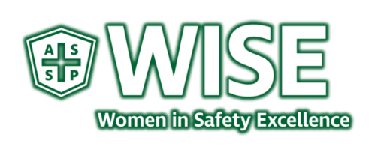
Activities slated for 2020-2021
WISE Members:
As we end the year of 2019-2020, we want to once again thank our core members who have provided activities and/or participated in support of those events throughout the year. Congrats to ASSP GSJC – WISE Section for receiving a 2020 ChapterWise Platinum Distinction award. Our WISE Committee 2019-2020 officers Charity and PDC – Dolores Bergen Technical Talk – Emilie Cherre / Eileen Woodbury STEM / Scholarship – Mary Stine / Ashli Sturgill Networking and Social – Julie Kreger-King
Due to the Shelter in Place, some events were moved to virtual events, and as such, we appreciate those who are speaking on behalf of WISE and/or for a WISE event through this media. For the upcoming Fall PDC, we have been advised by the Executive Committee that it will not be in person.
There are several activities to get involved in, and we are open to using more input in hosting or participating in these events. A survey will be placed in ASSP Survey Monkey the last week in June. We would like to meet and discuss those selected with the entire Chapter for input August 27, 2020.
We are improving our communication of events. In June 2019 – we established a Section online and a NEWS page to find out what is coming up: https://sj.assp.org/news-wise/ We now also have an APP at the Mighty Networks – The Greater San Jose Chapter Wise. Consider joining the WISE Committee activities led by our fine members. https://sj.assp.org/sections-wise/
July 2020:
July 2, 2020 – EHS Global Panel on the EHS profession and its value in today’s industry. Hosted on Zoom Media.
July 13, 2020 – Society of Women Engineers and Idaho State University host WISE to complete an experiment during the STEM Summer camp. This was recorded in June 2, 2020 with Wiser Dolores Bergen and Mary Stine and SWE Mackenzie Gorham Instructor, Nuclear Operations. Hosted on ZOOM
July 24, 2020 – STEM Summer Professional Development Series as a part of the Army’s education Outreach Program. These are rising sophomores to recent post bachelors who meet Fridays at Noon and will be 45-60 minutes each. There are two more slots open, we have August 7 and August 14 if you are interested.
July 28, 2020 – almost sold out - Eventbrite and FB post for EHS Burnout and how to use tools to prevent or recover from it. The guest speaker is a member of the San Francisco Chapter and a professional business owner for the last 10 years.
We have files for descriptions of each position and each leader occupying currently. We are looking for venues, sponsors for swag purchases and event expenses. Please reach out WISE@sj.assp.org to join events.

